Name: Kainaat Rafiq Hussain Makhani
Registration #: 2012296
Semester and Section: 7A
LAB 1

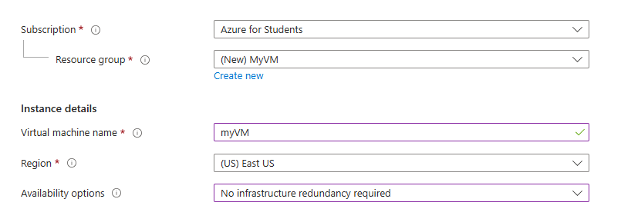

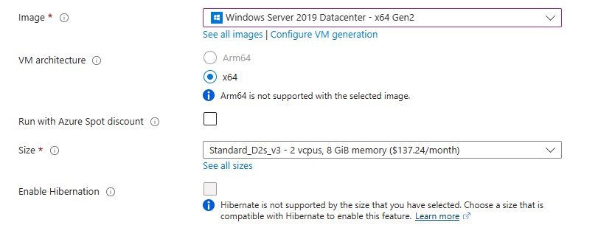

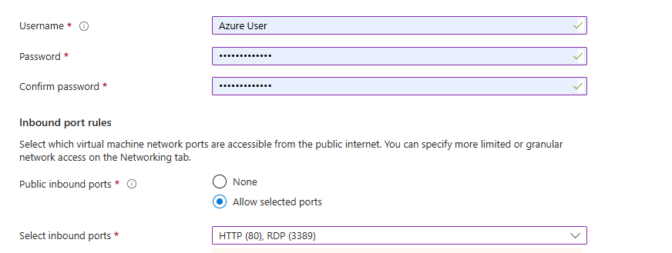

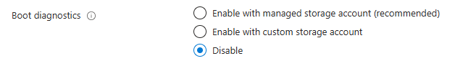

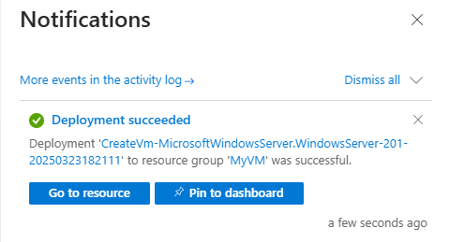

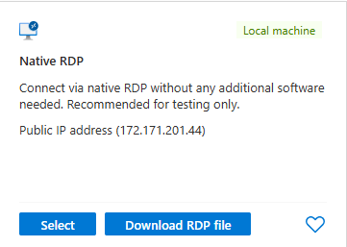

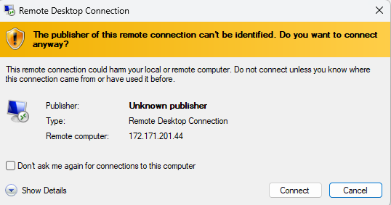

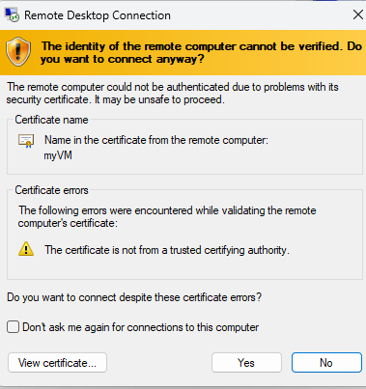

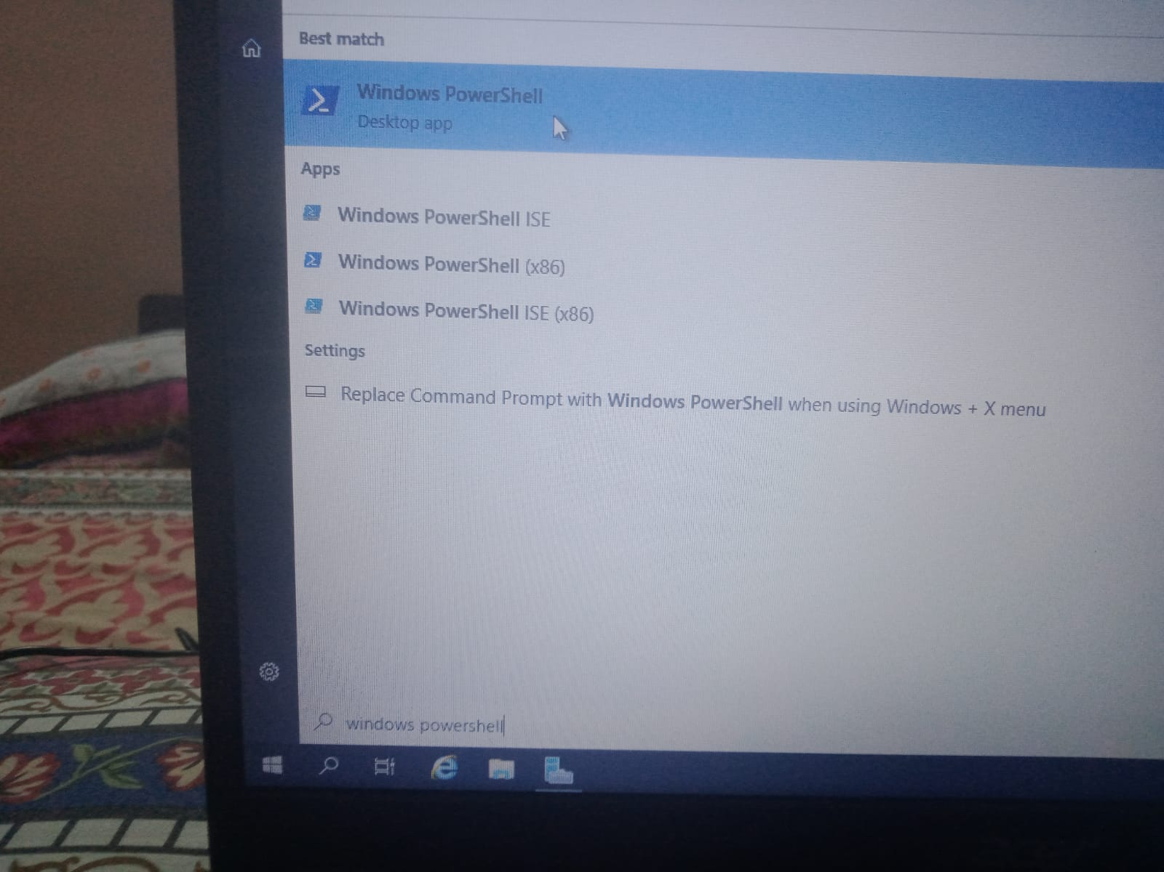

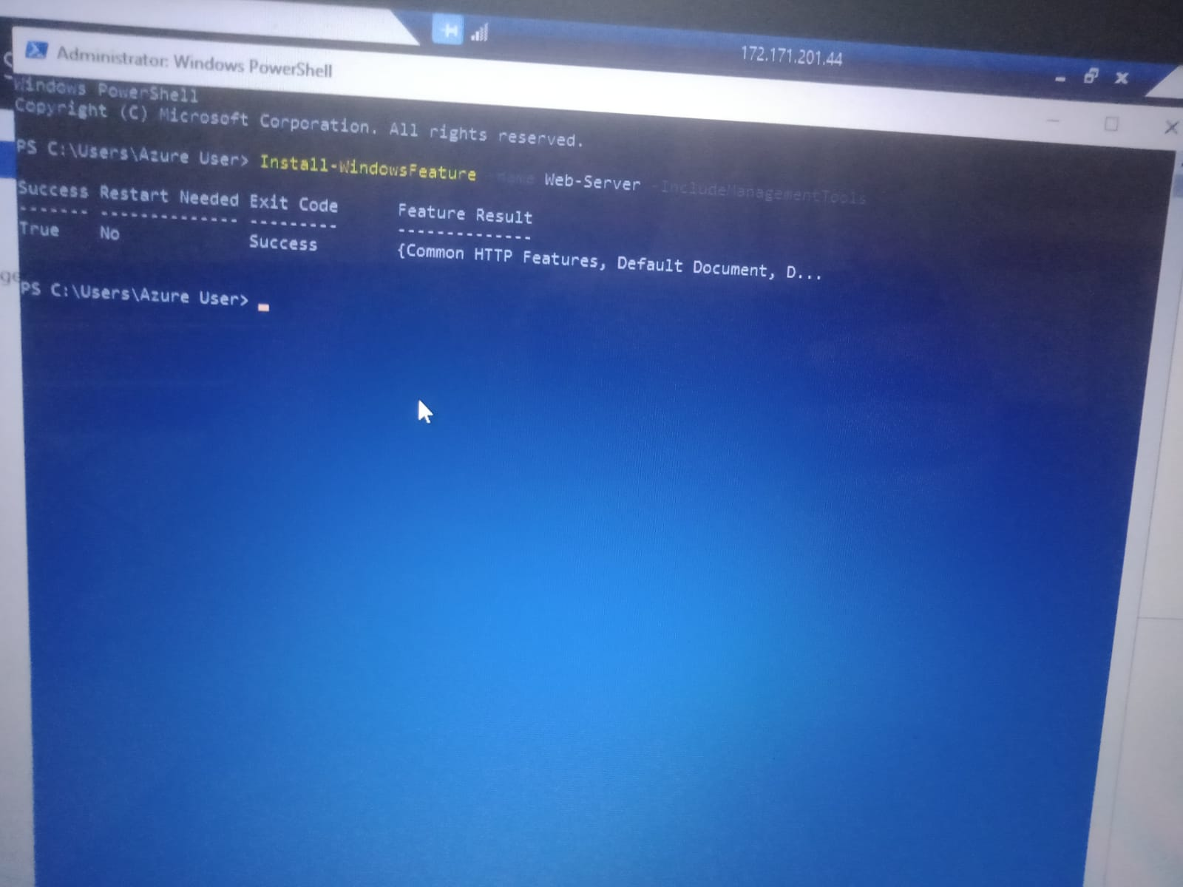

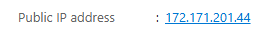

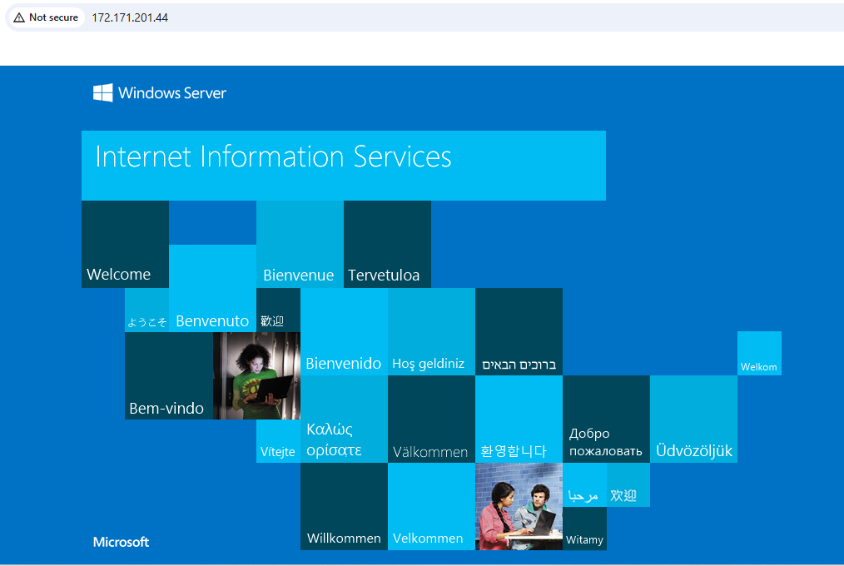

Description:
In this lab, we used the Azure Portal to create a virtual machine (VM) running Windows Server 2019 Datacenter. We configured basic settings like VM name, size, region, and administrator credentials. Specific inbound ports such as RDP (3389) and HTTP (80) were allowed to enable remote access and web server testing.
After deployment, we connected to the VM using RDP, launched the Server Manager, and installed the Web Server (IIS) role. Finally, we verified the successful installation by accessing the IIS welcome page through the public IP address of the VM in a web browser.

